**Question 1**

Use the Davis Putnam procedure to prove or disprove satisfiability of the formula  
(a V b V c) & (b V not c V not f) & (not b V e)

**Answer 1:**

**(Pure Literal) a = 1**

**(Simplify) ( b ∨ ¬c ∨ ¬f ) ∧( ¬b ∨ e )**

**(Pure Literal) f ` = 1, f = 0**

**(Simplify) ( ¬b ∨ e )**

**(Pure Literal) e = 1**

**(Simplify) all clauses satisfied, success.**

**Satisfiable. 🤔a=1, f=0, e=1 satisfies the original formula, independent of other variables.**

**Question 2**

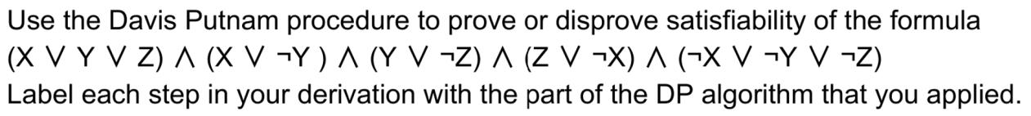

**Answer 2:**

**(Split) X = 1**

**(Simplify) ( Y ∨ ¬Z) ∧ (Z) ∧ ( ¬Y ∨ ¬Z)**

**(Unit Clause) Z = 1**

**(Simplify) ( Y ) ∧ ( ¬Y)**

**(Unit Clause) Y = 1**

**(Simplify) (())**

**(Backtrack) Empty Clause. X = 0**

**(Simplify) ( Y ∨ Z) ∧ (¬Y) ∧ ( Y ∨ ¬Z)**

**(Unit Clause) Y = 0**

**(Simplify) (Z) ∧ (¬Z)**

**(Unit Clause) Z = 1**

**(Simplify) (())**

**(Finish) Inconsistent.**

**Question 3**

a. ​​Use the Davis-Putnam algorithm to show if the following set of clauses is satisfiable or not. Label each step with its proper name, and choose the value 0 for the alphabetically lowest letter if you must choose.

(Q v R v ¬T), (Q v ¬R), (P v R v ¬S), T, (¬P v Q v R), (R v ¬U), (Q v ¬S v T), (R v ¬T v U), (¬Q v R), (P v ¬S v ¬T)

b. What is the maximum number of truth assignments that must be tried when executing the Davis-Putnam algorithm, and in which case does that occur?

**Answer 3:**

**(Unit Clause) T = 1**

**(Simplify) (Q v R), (Q v ¬R), (P v R v ¬S), (¬P v Q v R), (R v ¬U), (R v U), (¬Q v R), (P v ¬S)**

**(Split) P = 0**

**(Simplify) (Q v R), (Q v ¬R), (R v ¬S), (R v ¬U), (R v U), (¬Q v R), (¬S)**

**(Unit Clause) S = 0**

**(Simplify) (Q v R), (Q v ¬R), (R v ¬U), (R v U), (¬Q v R)**

**(Split) Q = 0**

**(Simplify) (R), (¬R), (R v ¬U), (R v U)**

**(Unit Clause) R=1**

**(Backtrack) Empty Clause. Q = 1**

**(Simplify) (R v ¬U), (R v U), (R)**

**(Unit Clause) R = 1**

**(Simplify) all clauses satisfied, success.**

**Satisfiable. 🤔T=1, P=0, Q=1, R=1 satisfies the original formula, independent of other variables.**

**b. In worst case, the maximum number of trying assignments is 2^n, where n is the number of variables.**